DAY 1
ROSENIVITHA J 192424009
DSA0414 LAB EXP
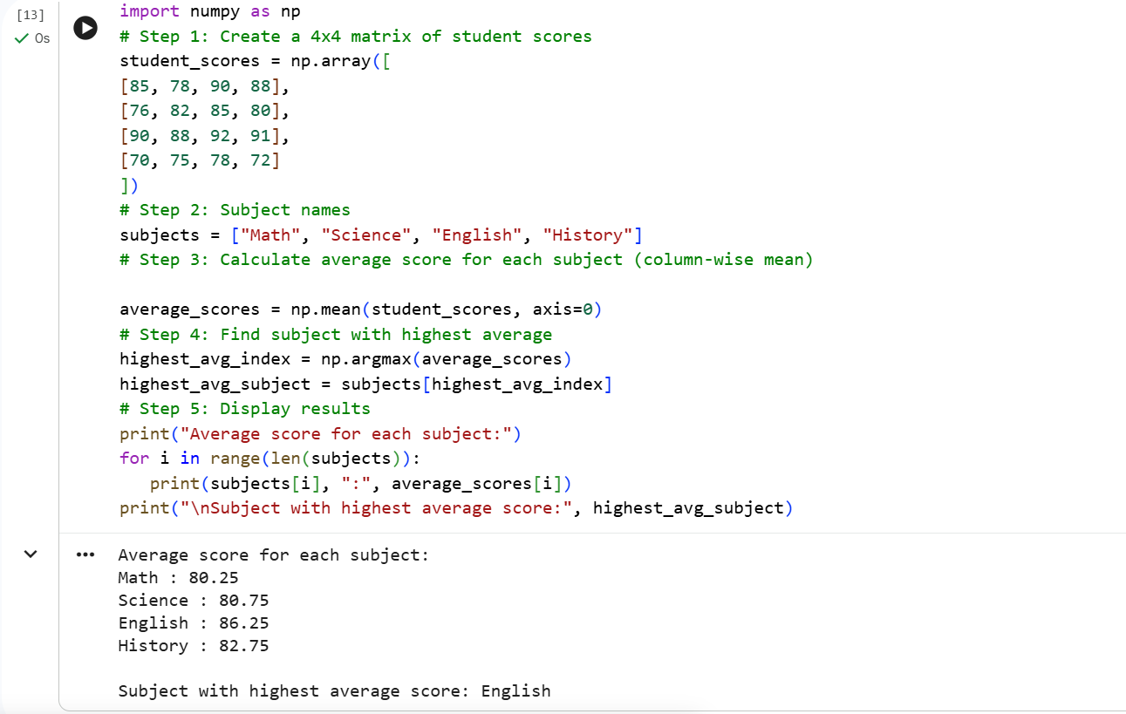
1

2
